INFOSYS SPRINGBOARD VIRTUAL INTERNSHIP MODULE-1
Name: Shiven Pratap Singh
Project Name: HotelRevAI AI Driven Revenue Analysis for Hotels_Batch -13

About the Project:

HotelRev Analyze is a data analytics project designed to track and evaluate hotel performance using booking and revenue data. The main goal is to study key performance indicators such as Occupancy Rate, Average Daily Rate (ADR), and Revenue Per Available Room (RevPAR) to understand how effectively hotel rooms are being used and how much income they generate.

In this project, raw booking data is first organized in Microsoft Excel, then cleaned and transformed using Power Query. After that, the data is further analyzed in Power BI by creating calculated measures and visual reports. This process turns unstructured data into clear, useful insights that highlight patterns in customer demand, pricing behavior, and seasonal trends.

The end result is an interactive Power BI dashboard that presents hotel performance through visuals like charts, KPI cards, and tables. These dashboards allow hotel management to easily track occupancy levels, compare revenue over different time periods, and make informed decisions to improve overall business performance.

MODULE 1:INTRODUCTION AND DATA PREPARATION

Objective:-

Module 1 focuses on building a realistic hotel booking dataset with the help of Python. Instead of using existing data, this module creates synthetic records for different entities such as customers, hotel locations, room categories, and booking details, allowing the dataset to mimic real-world hotel operations.
Once the data is generated, it is structured and saved into CSV files for easy access and compatibility. These files act as the base layer for the next stages of the project, where the data is cleaned, transformed, and analyzed using tools like Power BI to extract meaningful insights.

Step-1: GENERATE BASIC DATASETS

The data for this project was created using a Python program designed to replicate real hotel booking activities. It produces random yet structured information for different components such as customers, hotel locations, room categories, and booking records. Libraries like csv, random, and datetime were used to generate and organize the data efficiently.

After generating the dataset, it was saved in CSV format, making it easy to import and work with in tools like Power BI. These files are then used in the next stage of the project for data cleaning, transformation, and detailed analysis.

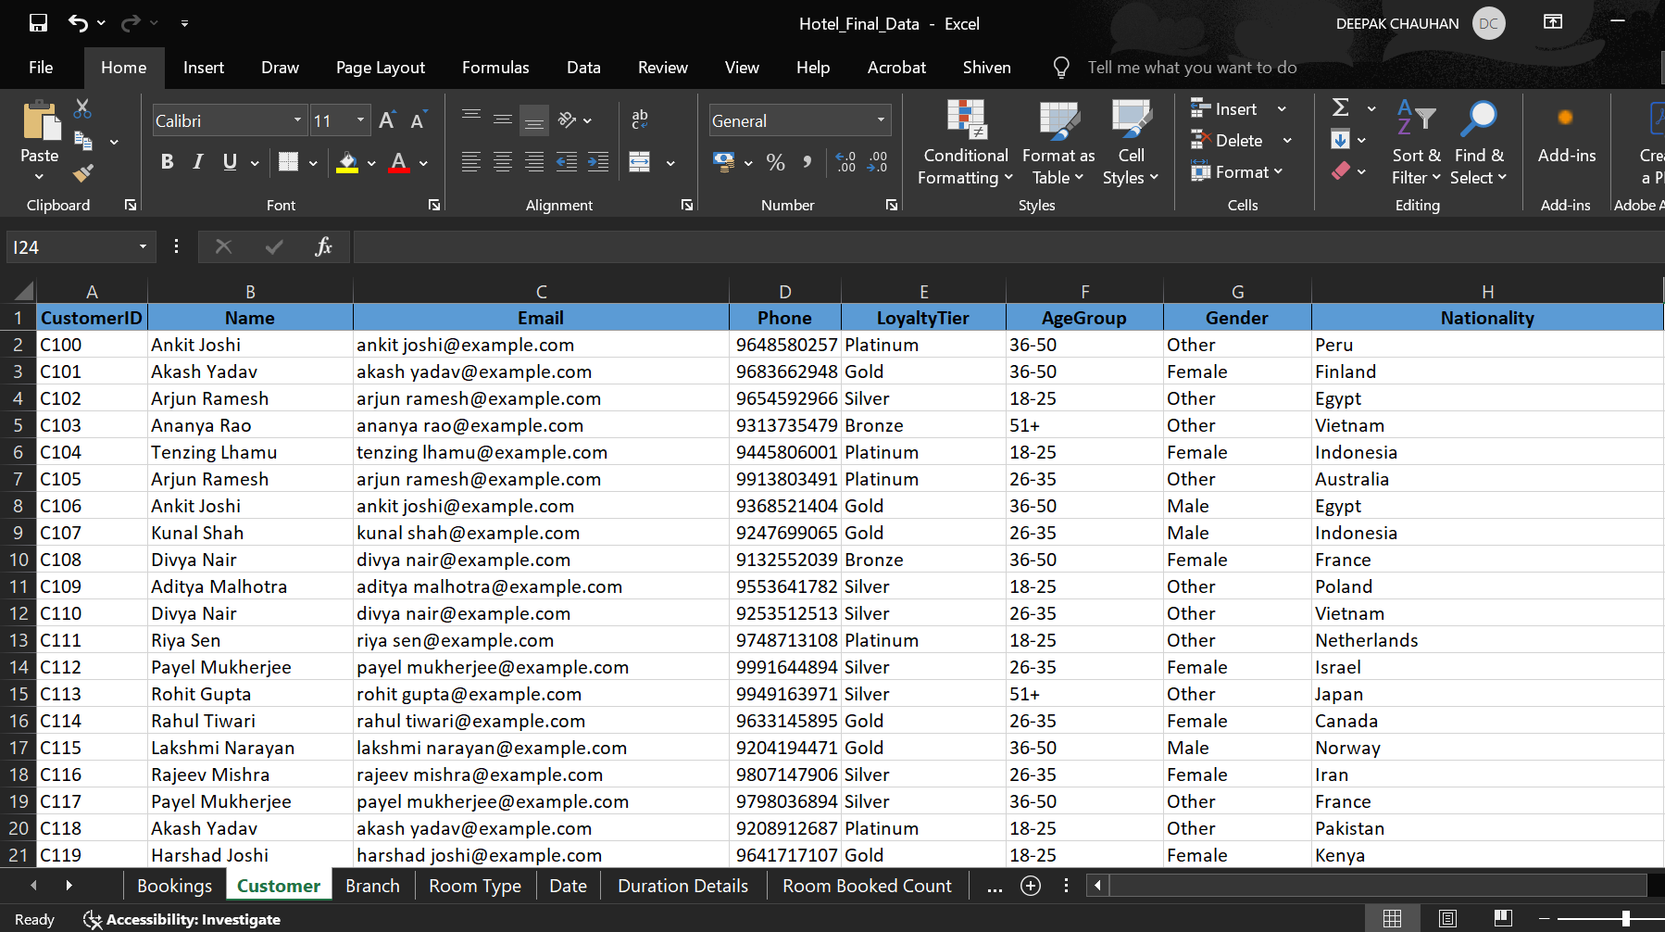

Customer.csv:

- CustomerID
- Name
- Email
- Phone
- Nationality
- Loyality tier
- Gender
- Age

Booking.csv:

- BookingID
- CustomerID
- RoomTypeID
- BranchID
- CheckInDate
- CheckOutDate
- Duration

- Revenue
- BookingStatus
- CancellationReason
- LeadTime
- PaymentMethod
- DiscountApplied
- BookingChannel

Branch.csv:

  - BranchID
  - BranchName
  - City
  - Phone
  - ManagerName
  - StarRating
  - HasPool
  - HasConferenceRoom

RoomType.csv:

  - RoomTypeID
  - RoomType
  - Price
  - MaxOccupancy
  - Amenities
  - IsAC
  - IsSeaFacing

Step-2: Creating Additional coulmns required for Analysis.

In the Booking.csv file, additional fields such as Stay Type and Room Nights Sold were included to enhance the quality of analysis. These attributes help provide a clearer understanding of booking patterns and improve the accuracy of performance metrics.

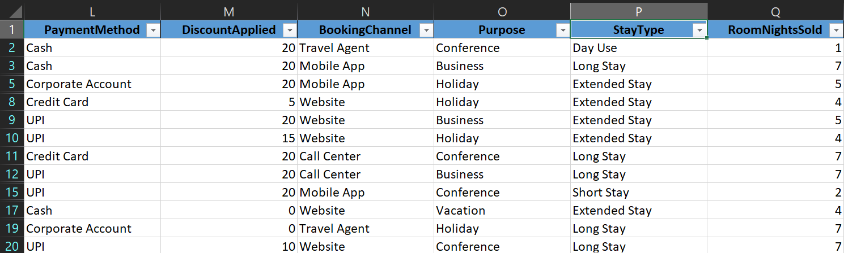

StayType Formula:

=IF(H2=1,"Day Use",

IF(H2<=2,"Short Stay", IF(H2<=5,"Extended Stay",
"Long Stay")))

RoomNightSold Formula:

=SUMIFS(H2, J2, "Checked-In")

Step-3: Importing the data into PowerBI

The finalized dataset files were brought into Power BI using the Get Data feature. This step enables the data to be loaded into the platform, where it can then be cleaned, structured, and used to build models and visualizations for deeper analysis.

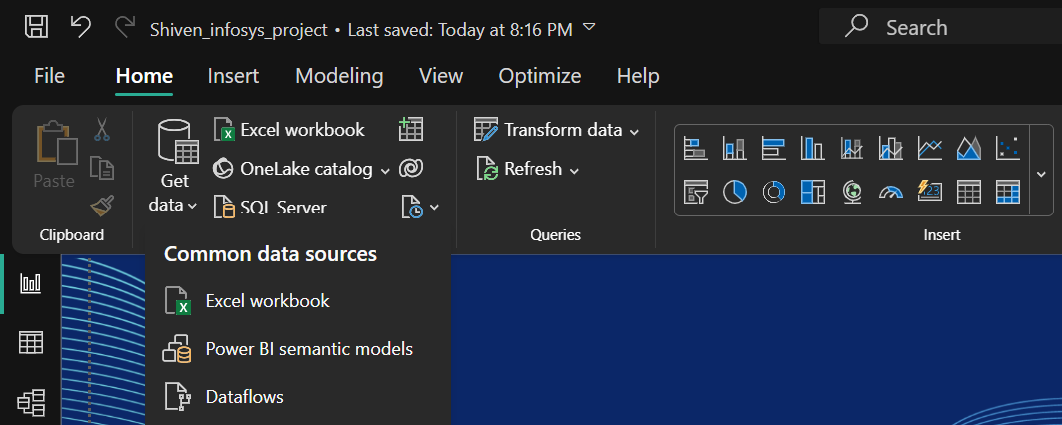
Select necessary tables and then click load
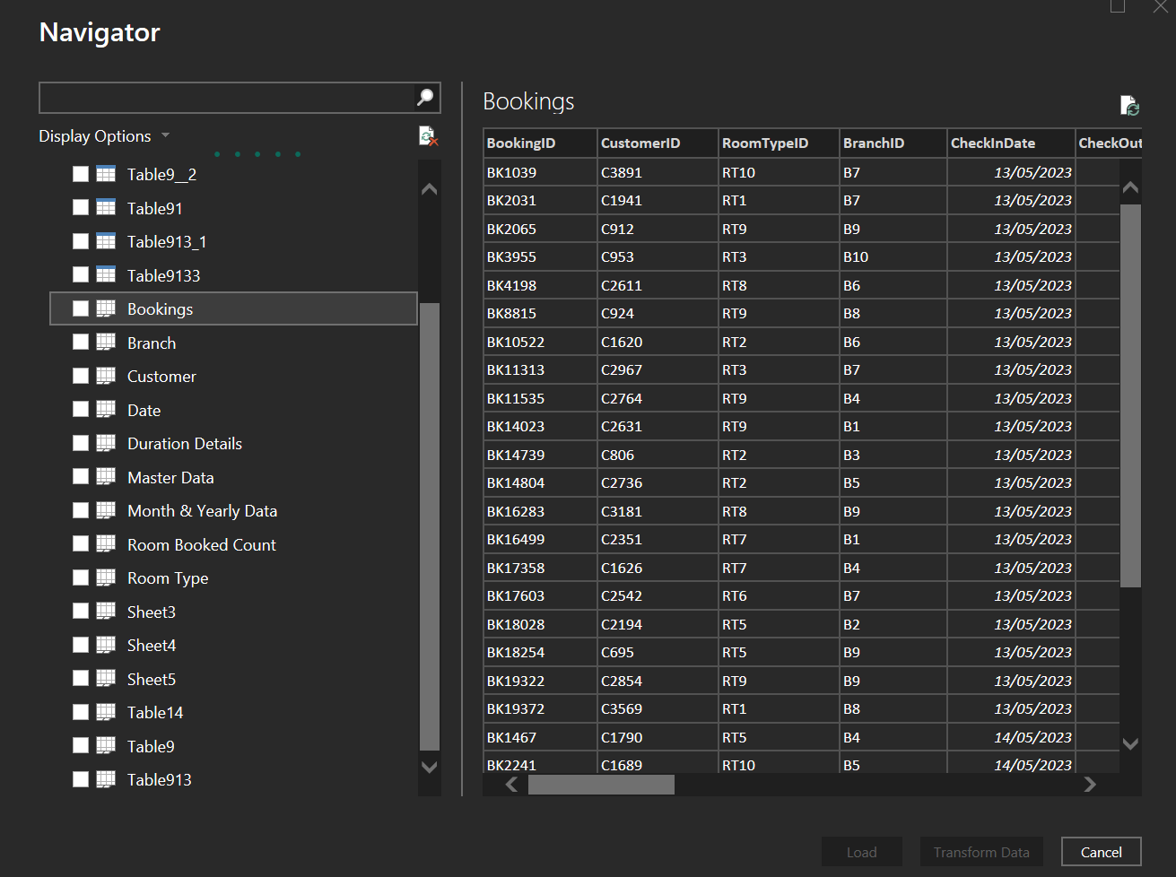

Step-3: Create STAR schema in PowerBI

Once the datasets were loaded into Power BI, a star schema model was designed to structure the data effectively. The central fact table (Booking) was linked to supporting dimension tables like Customer, Branch, and Room Type.

This modeling approach keeps the data well-organized and reduces complexity, making it easier to analyze. It also improves report performance and ensures faster, more efficient insights during visualization and reporting.

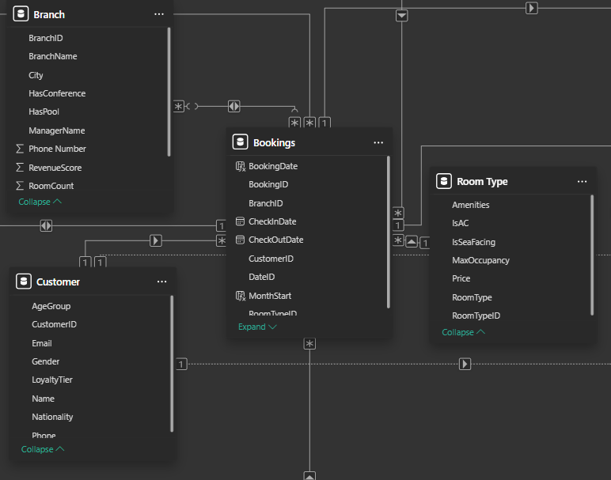
Relationships between the tables as given in the following figure:
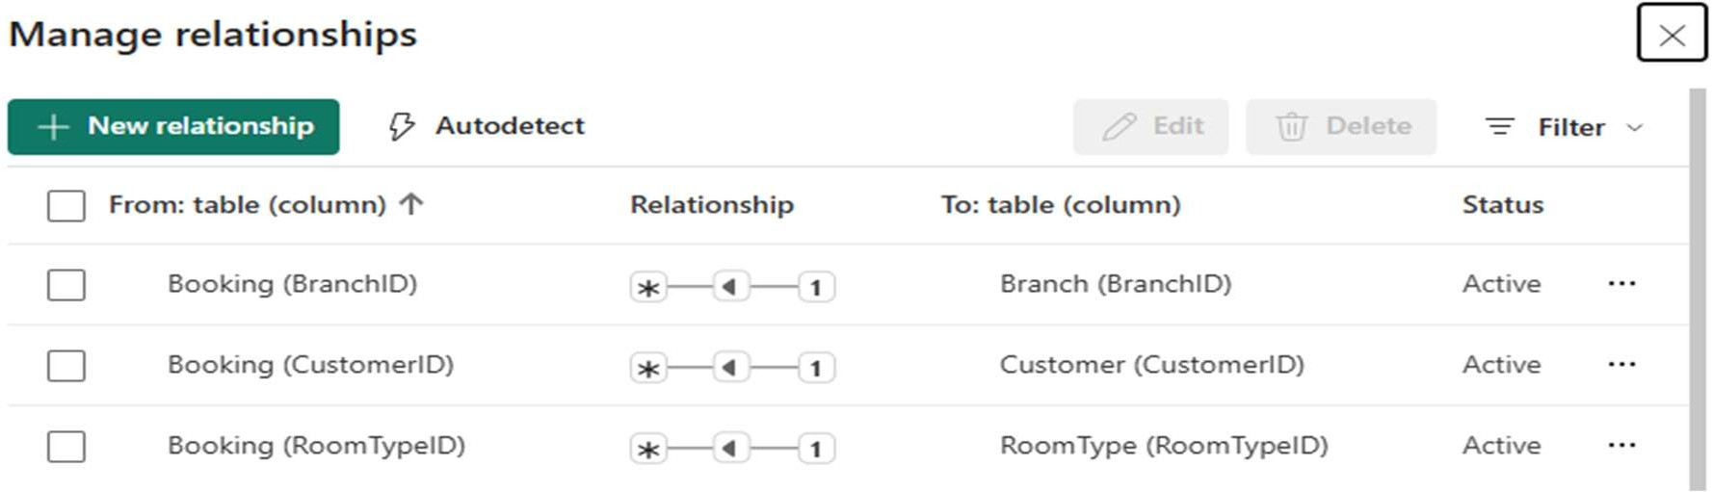

Conclusion:

In this module, all the necessary datasets for the hotel revenue analysis project were successfully created using Python. To enhance the data for analysis, additional columns were added with the help of Excel formulas. After preparing the datasets, they were imported into Power BI for further processing.
A star schema data model was then built to structure the data in a clear and efficient way. This setup makes it easier to perform transformations, carry out analysis, and create meaningful visualizations in the later stages of the project.

